Django Aws migration

Date: 11th jan 2021

Elastic beanstalk

Virtualenv

Python

Django

Download files from [aws/aws-elastic-beanstalk-cli-setup: Simplified EB CLI installation mechanism. (github.com)](https://github.com/aws/aws-elastic-beanstalk-cli-setup) for Elastic beanstalk EBCLI

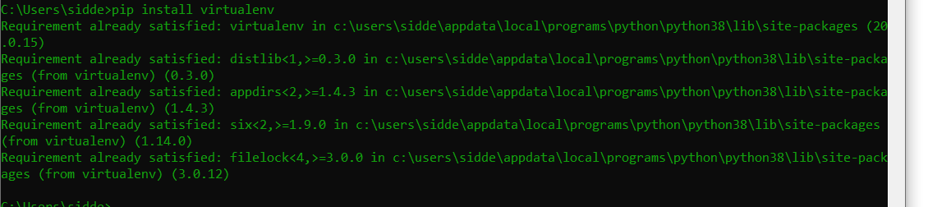

git clone https://github.com/aws/aws-elastic-beanstalk-cli-setup.git

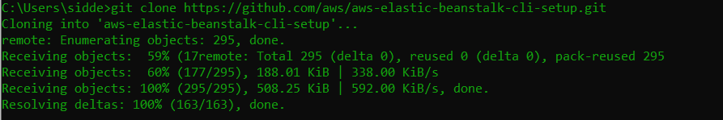

.\aws-elastic-beanstalk-cli-setup\scripts\bundled_installer

Create a virtual environment and make your Django project



Python3 -m venv “name_of_virtual_env”

Activate your virtual environment:

“nameOfvirtualenv”/bin/activate

Virtualenv is activated.

Now we will install Django and all the necessary packages.

Pip install Django==2.1.1

Pip freeze

Start Django project:

Django-admin startproject “projectname”

…..

Git repo to be setup to have a sync. With elb